`

Student Name | ANSWERS
Teacher | GSL | MDI | HAL | SMH

CHEMISTRY
Unit 4, SAC 1: Organic Chemistry
Test on concepts from Chapters 10-14 of Heinemann Chemistry 2
Monday 17th of August, Period 4
Writing time: 70 minutes

Structure of Report
Section | Number of questions | Number of questions to be answered | Number of marks
A | 10 | 10 | 10
B | 3 | 3 | 32
 |  |  | Total 42

- Students are permitted to bring into the assessment room: pens, pencils, highlighters, erasers, sharpeners, rulers and one scientific calculator.
- Students are not permitted to bring into the examination room: blank sheets of paper and/or white out liquid/tape.
Materials supplied
- This question and answer book of 12 pages.
- A data book
Instructions
- Write your name in the space provided above on this page.
- All responses must be written in English.
- Working out must be shown for all calculations
- Do NOT write on the data book
At the end of the assessment session
- Wait silently for the supervisor to collect your question and answer booklet and data book.
Students are NOT permitted to bring mobile phones and/or any other unauthorised electronic devices into the examination room.
Students must not disclose the contents of the task; to do so will be a breach of VCE guidelines and will be dealt with according to VCAA regulations.

SECTION A: Multiple-choice questions
Instructions for Section A
Answer all questions in pencil on the answer sheet provided for multiple choice questions.
Choose the response that is correct or that best answers the question.
A correct answer scores 1, an incorrect answer scores 0.
Marks will not be deducted for incorrect answers. No marks will be given if more than one answer is completed for any question.

Question 1
The number of structural isomers of C₄H₉Cl is:
- 2
- 3
- 4
- 5

Question 2
A major component of some nail polish removers is ethyl ethanoate. The correct semi-structural formula for ethyl ethanoate is:
- CH₃COOCH₂CH₃
- CH₃CH₂COOCH₃
- CH₃COOCH₃
- CH₃CH₂COOCH₂CH₃₁

Question 3
The number of hydrogen atoms in a molecule of 2,4-dimethyl-4-hydroxypentanoic acid is:
- 12
- 13
- 14
- 15

Question 3
Consider the molecule
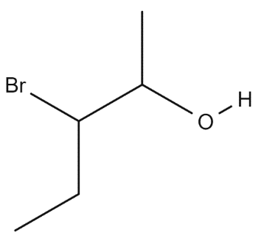
The IUPAC name for this molecule is:
- 2-bromo-1-methyl-butatan-1-ol
- 2-hydroxy-3-bromo-pentane
- 3-bromo-2-hydroxypentane
- 3-bromopentan-2-ol

Question 5
Hydrogen chloride gas can react with but-1-ene to produce 1-chlorobutane. This type of reaction is called:
- substitution
- oxidation
- hydrogenation
- addition

Question 6
The measurement that would be most useful in identifying an unknown substance separated by HPLC would be the:
- total distance moved by the substance along the stationary phase
- time taken for the substance to pass through the instrument
- height of the peak produced by the substance
- total area under the peak produced by that substance

Question 7
The low resolution H-NMR spectrum of the substance CH₃CH(OH)CH₃ would consist of:
- three peaks
- four peaks
- two singlets and two triplets
- one singlet, one doublet and one septet

Question 8
Two chemical containers have lost their labels. One contains ethanol and the other ethanoic acid. The most appropriate instrumental analysis to use to identify and determine the concentrations of the organic molecules is:
- HPLC
- ¹H-NMR spectroscopy
- calorimetry
- ¹³C-NMR spectroscopy

Question 9
In a titration of a strong base with a strong acid, the following procedure was used:
1. A burette was filled with the standard acid.
2. A pipette was rinsed with some base solution.
3. A conical flask was rinsed with some base solution.
4. A pipette was used to transfer a measured volume of base solution into the conical flask.
5. Indicator was added to the base sample and it was titrated to the endpoint with the acid.
Which statement is correct?
- The calculated base concentration will be correct
- The calculated base concentration will be lower than the real value
- The calculated base concentration will be higher than the real value
- The endpoint will be the same as the equivalent point

Question 10
A redox titration is carried out by adding purple KMnO₄ oxidant solution from a burette to a solution of H₂O₂ in a conical flask, under acidic conditions. Which of the following would correctly describe the observed colour and the product formed in the conical flask before the equivalence point is reached?

 | Observed Colour | Product Formed
 | purple | H₂
 | purple | O₂
 | colourless | H₂
 | colourless | O₂

END OF SECTION A
Section A: Multiple Choice Answer Sheet
This answer sheet must not be detached from this booklet.

INSTRUCTIONS FOR MULTIPLE CHOICE ANSWER SHEET
Use a PENCIL for ALL entries. For each question, shade the box which indicates your answer.
Marks will NOT be deducted for incorrect answers.
NO MARK will be given if more than one answer is completed for any question.
If you make a mistake, ERASE the incorrect answer - DO NOT cross it out.

1 |  | A |  | B |  | C |  | D
2 |  | A |  | B |  | C |  | D
3 |  | A |  | B |  | C |  | D
4 |  | A |  | B |  | C |  | D
5 |  | A |  | B |  | C |  | D
6 |  | A |  | B |  | C |  | D
7 |  | A |  | B |  | C |  | D
8 |  | A |  | B |  | C |  | D
9 |  | A |  | B |  | C |  | D
10 |  | A |  | B |  | C |  | D

SECTION B Short Answer Questions

Instructions for Section B
Answer all questions in the spaces provided. Write using black or blue pen.
To obtain full marks for your responses you should:
- Give simplified answers with an appropriate number of significant figures to all numerical questions; un-simplified answers will not be given full marks.
- Show all working in your answers to numerical questions. No marks will be given for an incorrect answer unless it is accompanied by details of the working.
- Make sure chemical equations are balanced and that the formulas for individual substances include an indication of state; for example, H₂(g); NaCl(s)

Question 1 (8 marks)
Butan-1-ol has the chemical formula C₄H₉OH.
- Write the IUPAC name of three other possible isomeric alcohols with the formula C₄H₉OH.
3 marks
- butan-2-ol
- 2-methyl-propan-2-ol (or methylpropan-2-ol
- 2-methyl-propan-1-ol (or methylpropane-1-ol)

- In the presence of an acidified solution of potassium dichromate (K₂Cr₂O₇), butan-1-ol reacts to produce an acidic product.
- Write the semi-structural formula of the acidic product. 1 mark
CH₃CH₂CH₂COOH

- Write the complete balanced equation for the oxidation of butan-1-ol. 2 marks
Reduction: $6e^{-}+14H^{+}\left(aq\right)+{Cr}_{2}O_{7}^{2-}\left(aq\right)→2{Cr}^{3+}\left(aq\right)+7H_{2}O(l)$
Oxidation: CH₃CH₂CH₂CH₂OH (l) + H₂O(l) → CH₃CH₂CH₂COOH (aq) + 4 H+(aq) + 4e⁻
Overall: 3 CH₃CH₂CH₂CH₂OH (l) + 16 H+(aq) + 2 Cr₂O₇²⁻(aq) → 3 CH₃CH₂CH₂COOH (aq) + 4Cr³⁺ (aq) + 11 H₂O(l)

(sub/superscripts not required, 1 mark per balanced equation, states not needed)

- The presence of the acidic product can be confirmed by distilling and collecting the product, then testing it with solid sodium carbonate. Describe what would be expected to be observed when the acidic product is mixed with the solid sodium carbonate and write a chemical equation for the reaction. 2 marks
Observation: bubbles due to the formation of carbon dioxide (1 mark)
Chemical equation: 2 CH₃CH₂CH₂COOH (l) + Na₂CO₃ (s) → 2 CH₃CH₂CH₂COO⁻ (aq) + 2 Na⁺ (aq) + CO₂ (g) + H₂O (l)
(sub/superscripts not required, 1 mark per balanced equation, states not needed)

Question 2 (13 marks)
Compounds A, B and C are isomers of C₅H₁₀O₂.
- Isomer A is a butyl ester. Draw the skeletal structure of A. 1 mark

1

- Isomer B is the compounds shown below. Some of the carbons have been labelled (m and n).

n
m

- Deduce the number of peaks in the ¹³C-NMR spectrum of Isomer B. 1 mark
5 peaks

- What is the expected chemical shift for the carbons labelled m and n? 2 marks
Carbon m: 50-90 ppm
Carbon n: 205-220 ppm

(must include value and units. If units missing for both, pay 1 consequential for second correct number with no units)

- Isomer C is the acid shown below. Some of the protons have been labelled.
x
y

- Deduce the number of peaks in the ¹H-NMR spectrum of Isomer C. 1 mark
4 peaks

- What is the expected splitting patter for the proton environments labelled x and y? 2 marks
Proton environment x: doublet
Proton environment y: singlet

- The IR spectrum of one of these isomers is shown below.
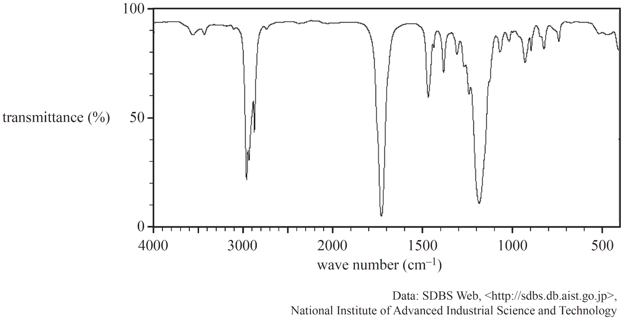
- Describe the physical principles behind IR spectroscopy. 3 marks
1m – covalent bonds can vibrate (stretch bend).
1m – These vibrational modes can be excited with infrared radiation.
1m – different bonds (with different bond energies) will absorb specific frequencies of IR radiation. Therefore different functional groups will absorb specific frequencies that can be interpreted on a spectra as a wavenumber
(for the last mark they must make a link between different frequencies of radiation and different types of bonds/functional groups)

- Identify which one of the three isomers, A, B or C, produced the IR spectrum above. Justify your answer with supporting evidence from the IR spectrum. 3 marks
1m – bands present (~1700cm⁻¹ C=O, and ~3000cm⁻¹ –CH)
1m – bands missing (broad –OH (acid) ~2500-3500cm⁻¹ and broad –OH(alcohol) ~3200-3600cm⁻¹)
1m – Must be isomer A (ester) which has C=O and –CH but no -OH

Question 3 (11 marks)
- The following diagram represents a reaction pathway for the synthesis of compound C from but-1-ene.
----
but-1-ene
Compound A
Name: 2-chlorobutane
HCl
H⁺/MnO₄²⁻
Compound C
Structural formula:
CH3CH2COCH3
CH₃CH₂CH(NH₂)CH₃
Reagent/Conditions:
NH₃/alumina & heat
OH⁻
Compound B
Skeletal formula
Reaction type:
oxidation

- Give the IUPAC name of Compound A in the box provided. 1 mark
- When Compound A is reacted with hydroxide ions, Compound B is formed. Draw the skeletal formula for Compound B in the box provided. 1 mark
- Compound B can be converted into CH₃CH₂CH(NH₂)CH₃. Write the chemicals and conditions required for this conversion to occur in the box provided. 1 mark
- Identify the type of reaction occurring between Compound B and acidified permanganate (H+/MnO4-) in the box provided. 1 mark
- Draw the structural formula of Compound C in the box provided. 1 mark

- But-1-ene can be reacted with water, solid phosphoric acid and heat to produce two possible products, Y and Z.
- Give the IUPAC name for the both Compounds Y and Z. 2 marks
Compound Y: butan-1-ol
Compound Z: butan-2-ol

The mixture of products (Compound Y and Z) was separated using High Performance Liquid Chromatography (HPLC) with a polar stationary phase and a non-polar mobile phase. The following chromatogram with two peaks was obtained.
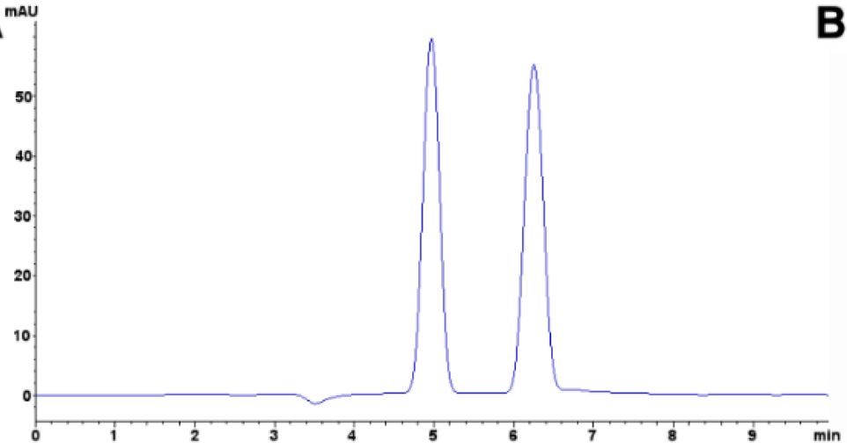
Absorption
Time
- Explain how the two compounds are separated as they travel through the HPLC column. 2 marks
1m – as the components are carried through the column, they adsorb to the stationary phase and desorb into the mobile phase
1m – the more polar components will be strongly adsorbed to the polar stationary phase while the less polar substance will be carried further by the non polar mobile phase. The less polar component will be eluted first or have shorter retention time

- Explain how could you identify which peak corresponds to each compound. 2 marks
1m run standard samples under identical conditions
1m compare retention times. If the samples have the same retention time, it can be assumed that they are the same compound.
or
1m spike the sample with some standard
1m look for the peak that increases in area. This ‘peak’ will correspond to the sample that is the same as the standard used for the spiking.
or
1m butan-1-ol is more polar then butan-2-ol (as the hydroxyl group is butan-2-ol is more crowded). Hence butan-1-ol will be more strongly adsobed to the polar stationary phase than butan-2-ol
1m Therefore, butan-2-ol will elute first at 5 min, followed by butan-1-ol at 6.3 min.

END OF TEST

